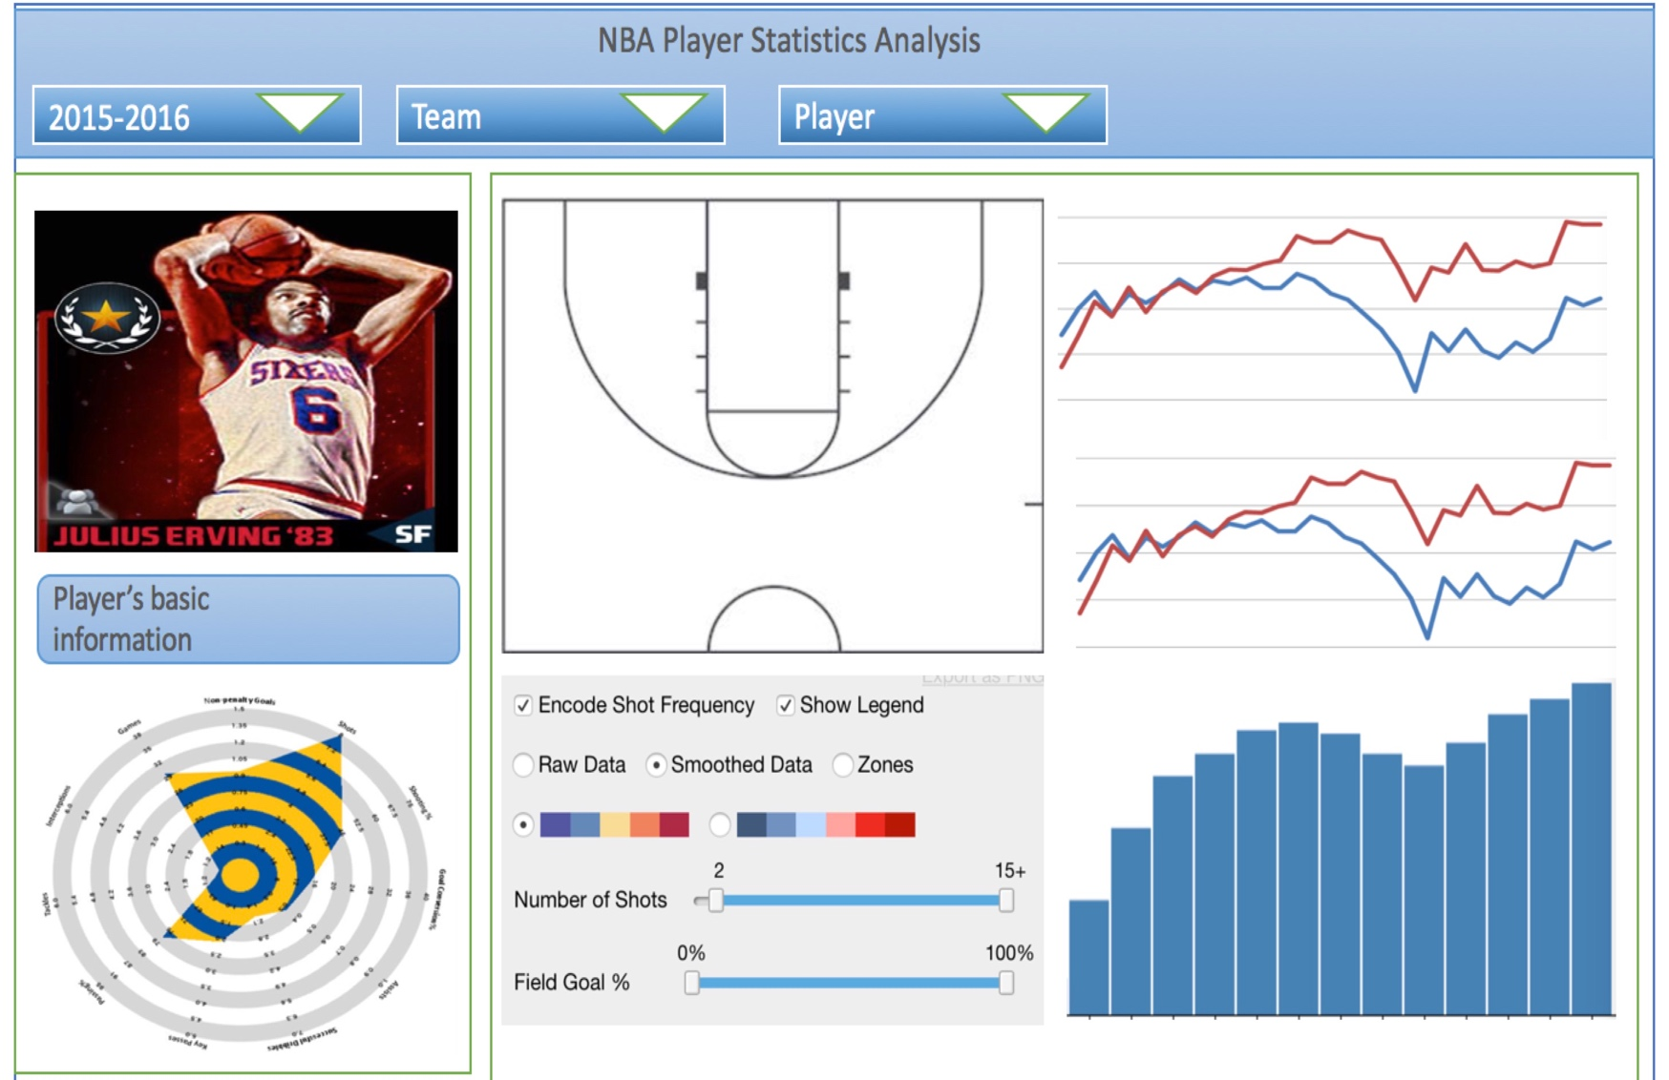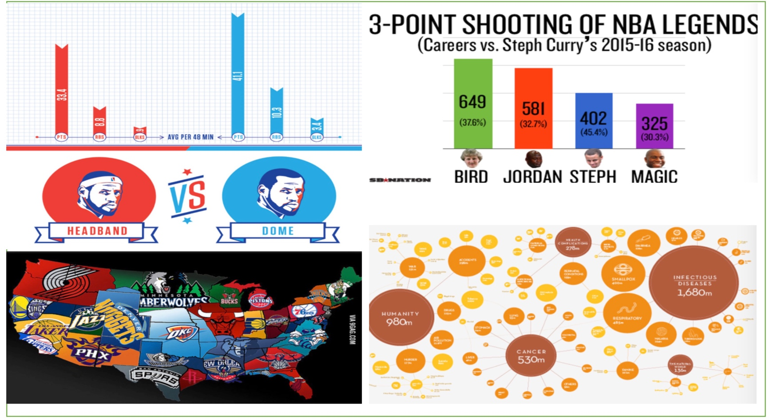

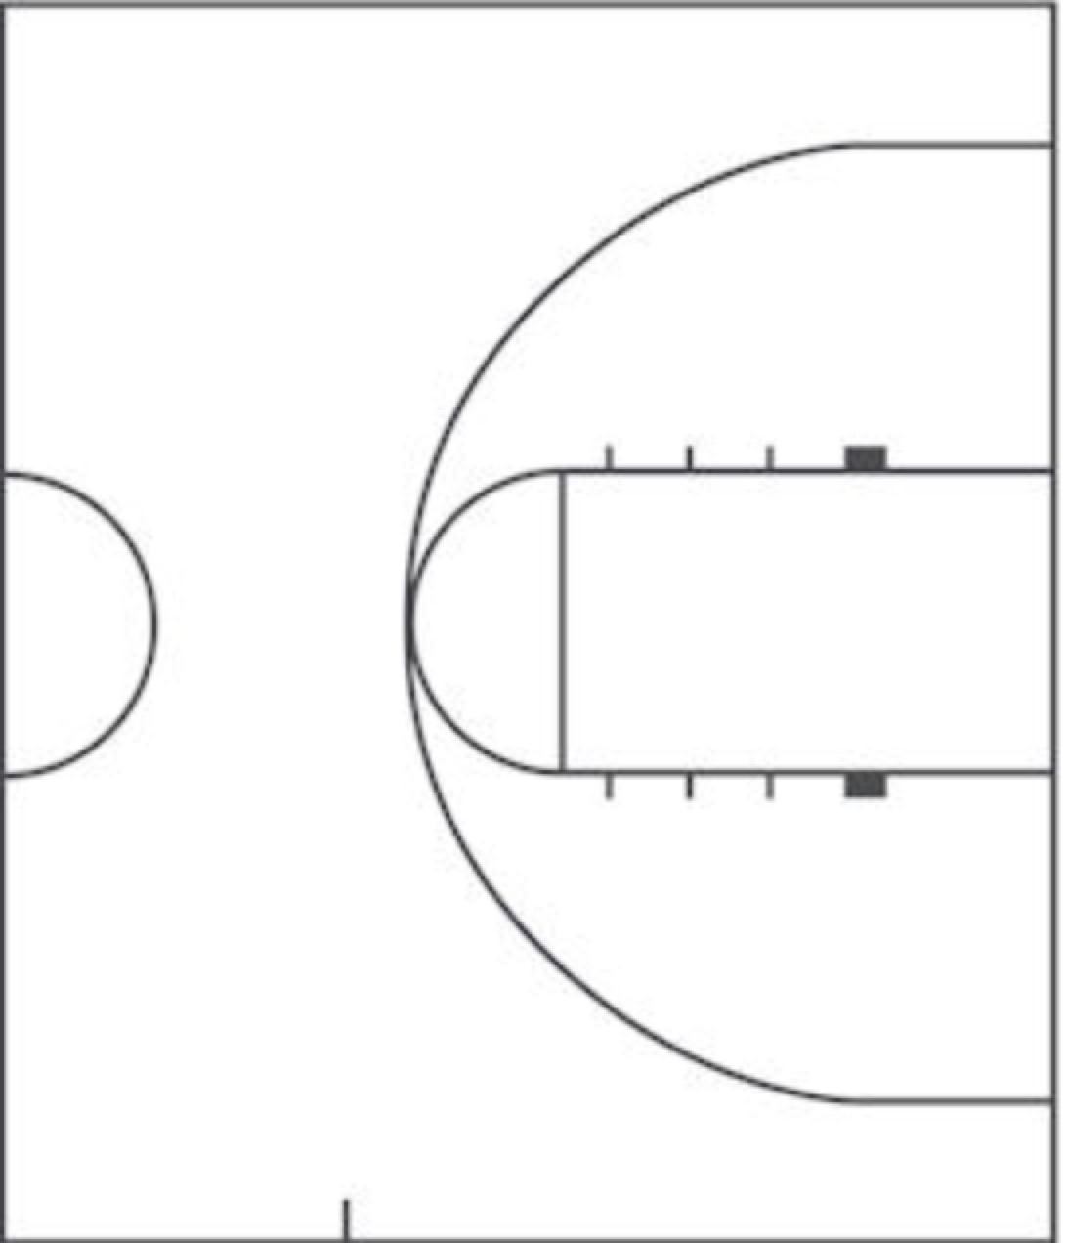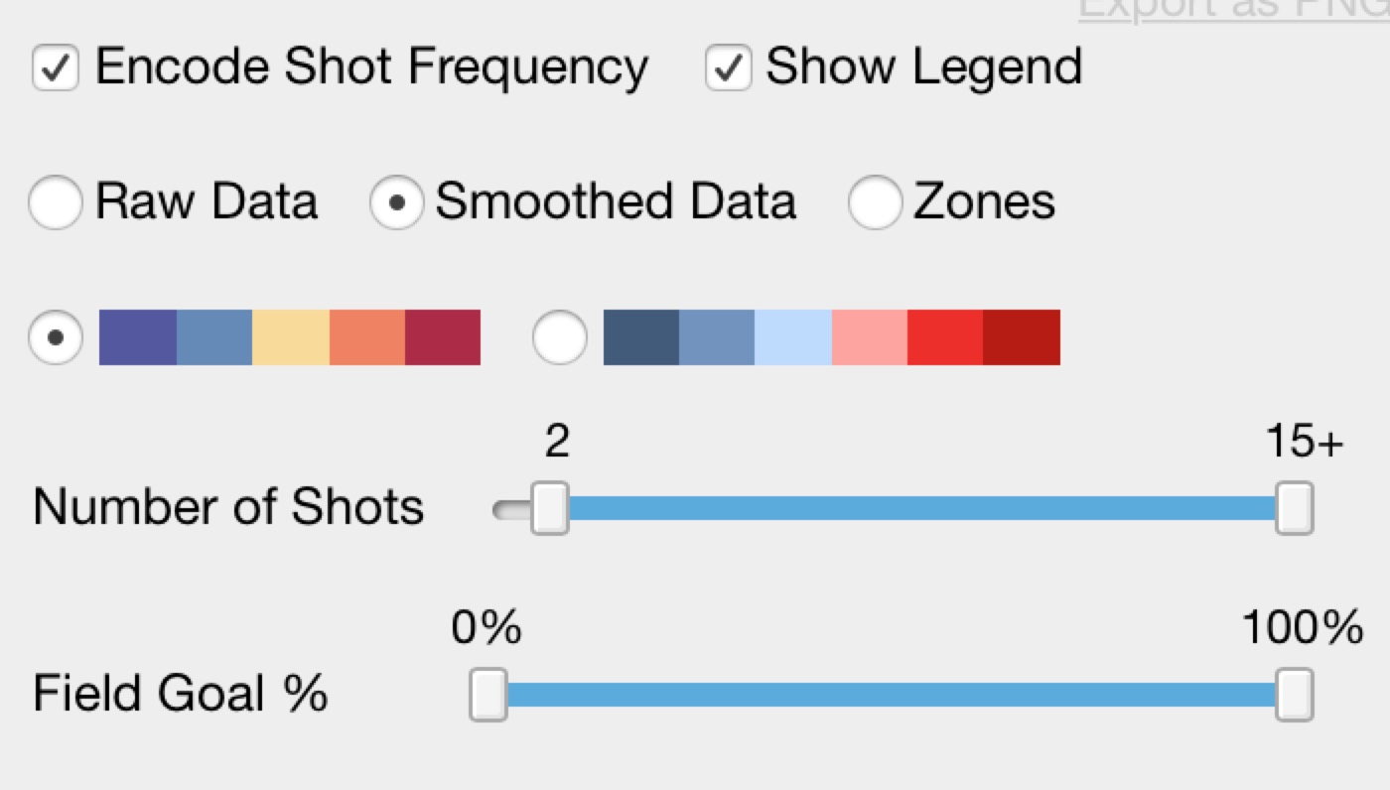

Here we use left position graph to represent the shooting frequency and goals, while the line chart on the right will interact with the position to shown the trend of goals and frequency based on the player’s information.

**Dynamic Interaction:**

Shooting frequency and goals

are changing with mouse hover.

**Dynamic Interaction:**

Shooting frequency and goals

are changing based on selected number of shots.

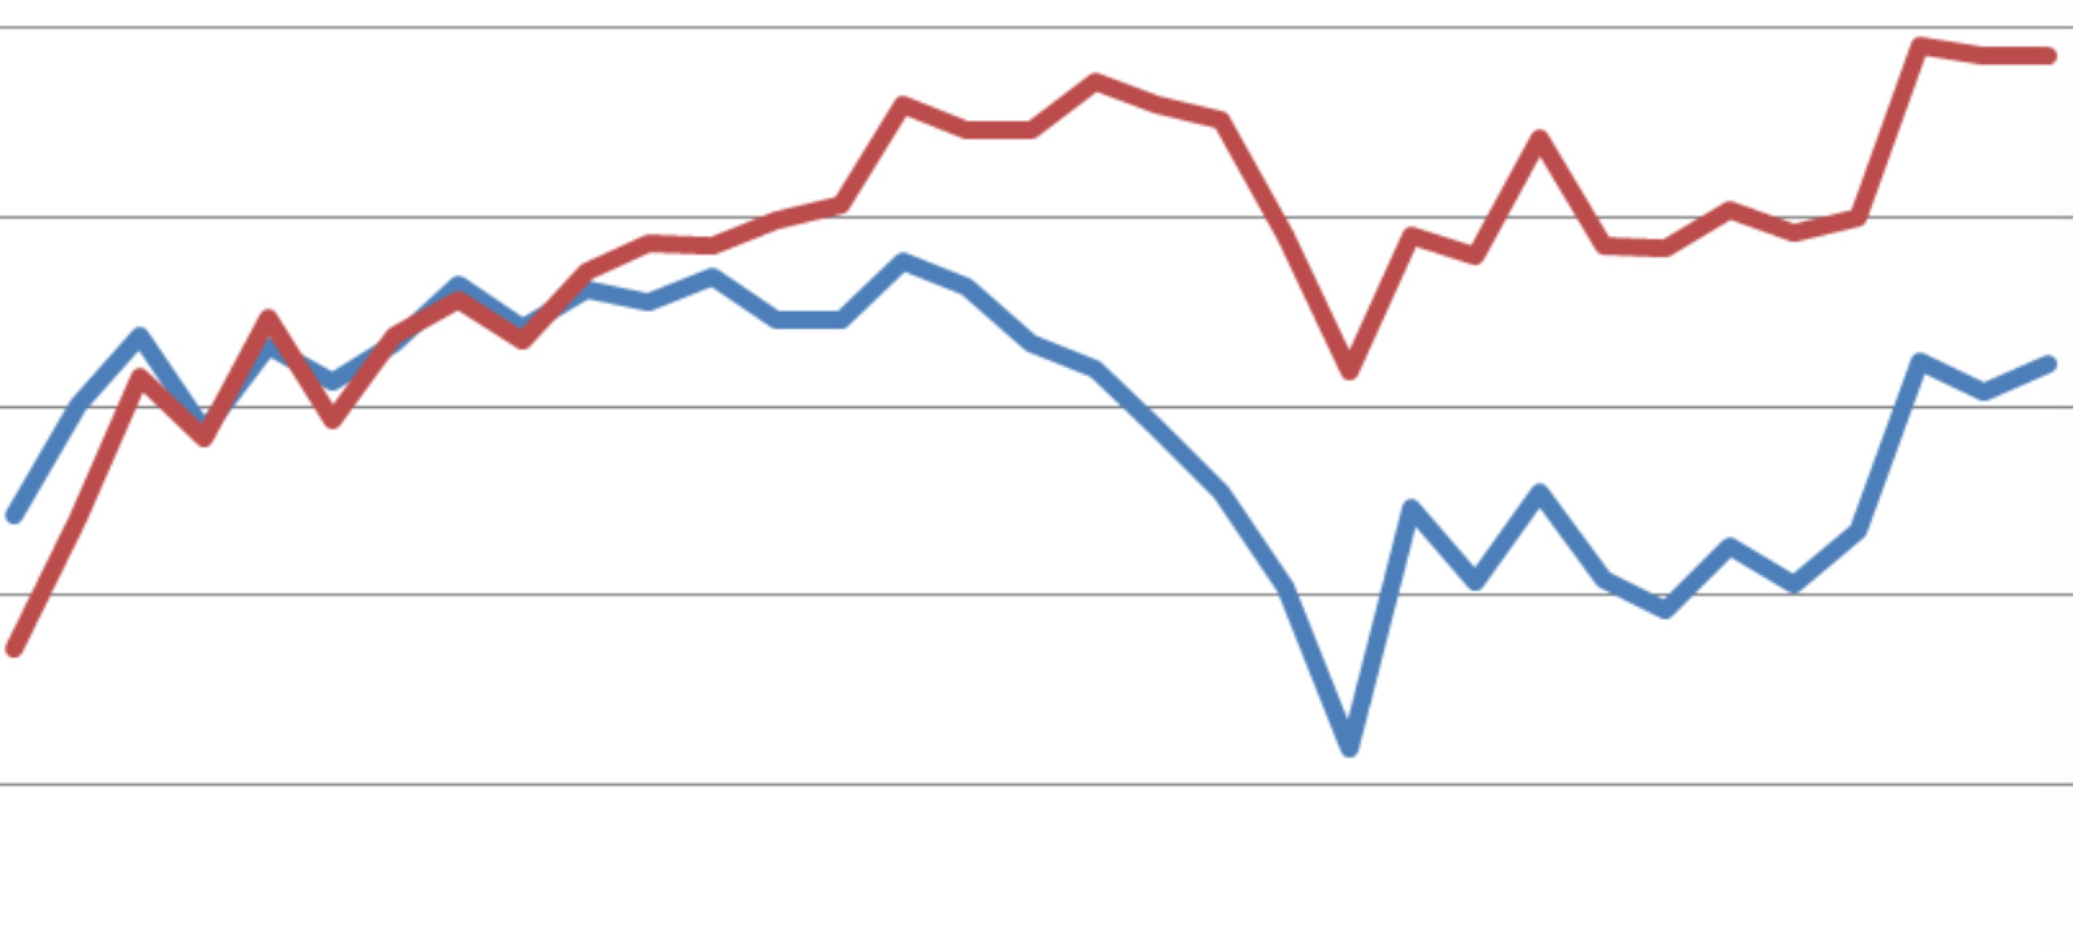

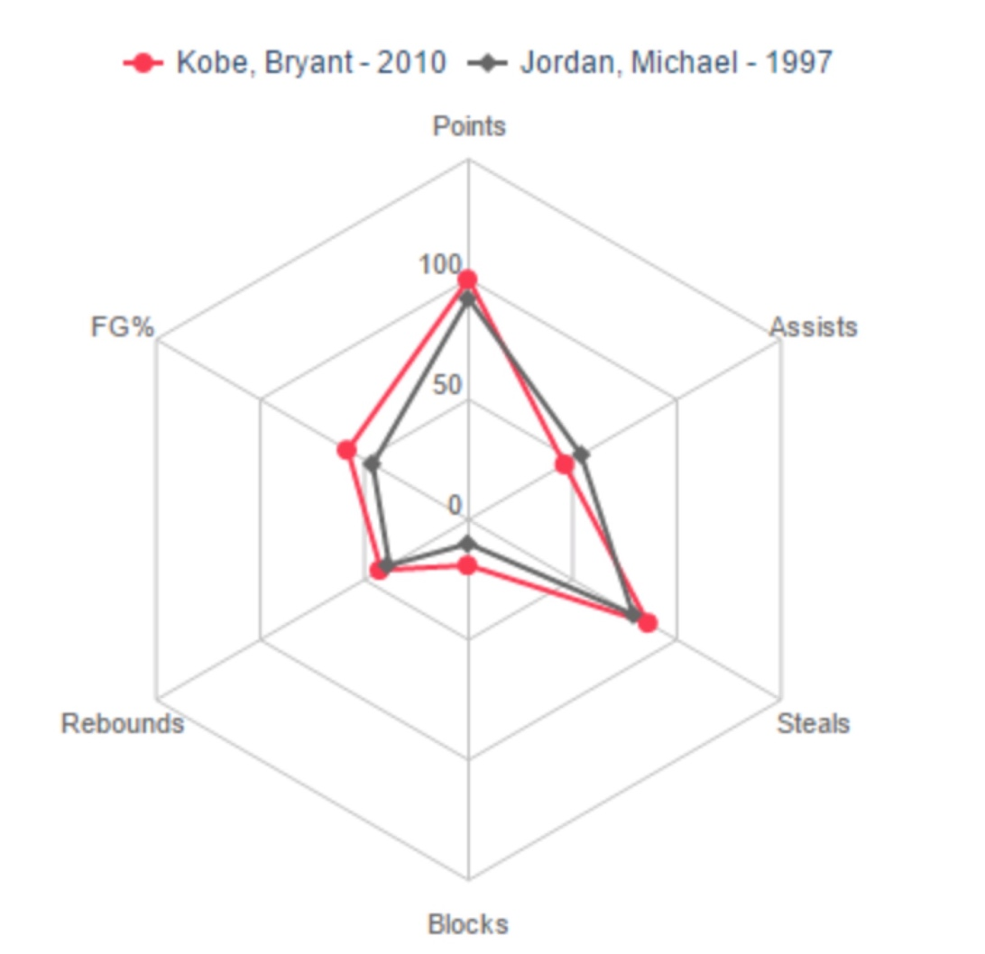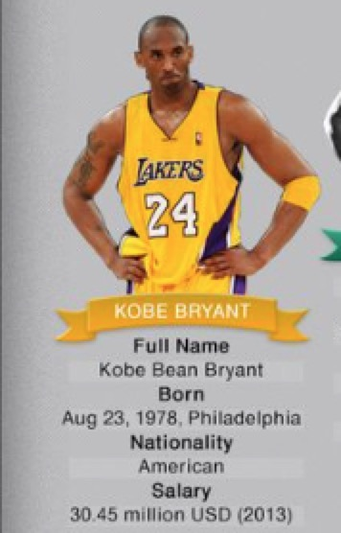

This part we will show each player’s basic information and performance radar chart based on different player’s abilities

compare Players performance (We can compare three players at same time)

